
National Textile University
Department of Computer Science
Subject:
Mobile Application Development
Submitted To:
Sir Rehan Sarwar
Submitted By:
Alishba Riasat
Registration No:
23-NTU-CS-1135
Lab No:
05
Semester:
6th

Task:
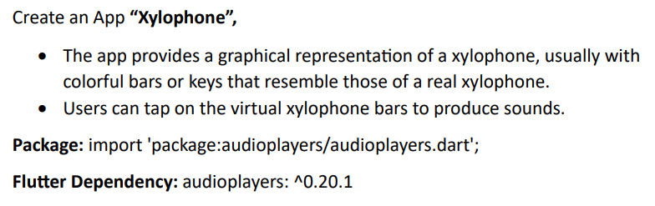

Code:
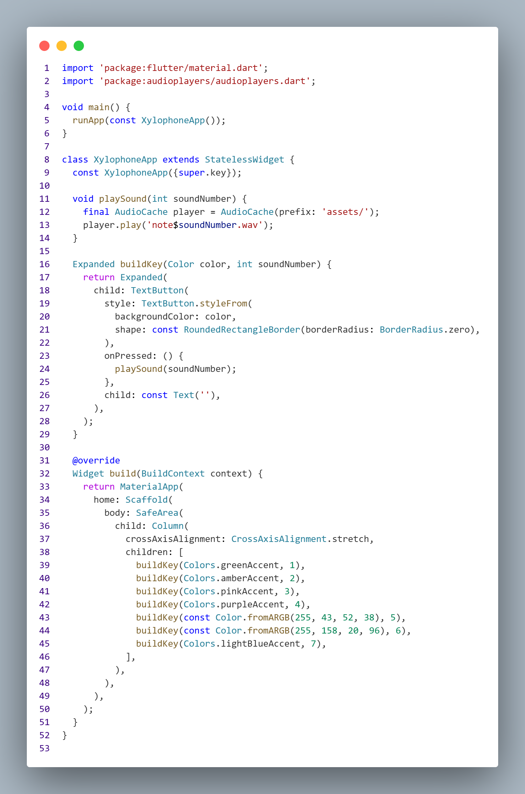
Output:
